Project Report
Project Title:
Measuring the Pulse of Prosperity: An Index of Economic Freedom Analysis
1. Introduction
Economic freedom plays a crucial role in shaping a country's prosperity, growth, and quality of life. The Index of Economic Freedom measures how supportive a country’s policies and institutions are toward economic freedom.
This project analyzes global economic freedom scores using data visualization tools to identify trends, patterns, and comparisons among countries.
The goal of this project is to:
- Understand economic freedom indicators
- Compare countries based on freedom scores
- Identify top and bottom performing nations
- Present insights through interactive dashboards and stories

2. Objective of the Project
The main objectives are:
- To analyze the Index of Economic Freedom dataset
- To visualize country rankings and economic scores
- To compare regional economic performance
- To build interactive dashboards
- To develop a story explaining insights
- To publish the project on GitHub and integrate it into a web application

3. Dataset Description
The dataset contains:
- Country Name
- Region
- Overall Economic Freedom Score
- World Rank
- 2022 Economic Freedom Score
The data helps in understanding how different countries perform based on economic policies such as:
- Business freedom
- Trade freedom
- Investment freedom
- Government integrity
- Fiscal health

4. Tools and Technologies Used
- Tableau Desktop – For data visualization
- Tableau Public – For publishing dashboards
- Git – Version control
- GitHub – Project hosting and repository management
- HTML & CSS – For webpage development
- Base44 – For integrating dashboard into website

5. Data Collection and Preparation
- Collected the dataset related to the Index of Economic Freedom.
- Cleaned and structured the data in spreadsheet format.
- Imported the dataset into Tableau Desktop.
- Verified accuracy and removed inconsistencies.

6. Dashboard Development
The dashboard was developed to visually represent:
- Global Economic Freedom Score Map
- Top 40 Ranked Countries
- Country-wise Score Comparison
- Regional Performance Analysis
The dashboard provides interactive filters and allows users to:
- Select countries
- Compare rankings
- Analyze score distribution
The dashboard is designed in a professional and clean layout to enhance readability and insight extraction.

7. Story Development
A Tableau Story was created to explain the insights step-by-step.
The story includes:
- Overview of 2022 Economic Freedom Score
- Global Map Visualization
- Top Ranked Countries
- Comparative Analysis
- Key Observations
The story helps users understand the data in a structured and meaningful way.

8. Key Insights
- Countries with higher economic freedom tend to rank better in global prosperity.
- Regional differences show variation in economic policies.
- Top-performing countries maintain strong business and trade freedom.
- Lower-ranked countries face structural and policy challenges.

9. GitHub Repository
The complete project files, webpage code, and documentation are available at:
👉 GitHub Link:
https://github.com/ARIGELASRIROJA/Measuring-the-Pulse-of-Prosperity-An-Index-of-Economic-Freedom-Analysis/
The repository includes:
- Project documentation
- Webpage source code
- Dashboard integration code
- Screenshots
- README file

10. Web Application Integration
The dashboards and stories were embedded into a professional webpage layout using HTML and CSS.
The webpage includes:
- Project title header
- Dashboard section
- Story section
- GitHub integration
- Responsive layout
- Medium-sized visualization display for better aesthetics

🔗 Project Deployment Link
Live Website:
https://economy-pulse-pro.base44.app

Screenshots:
Home page: 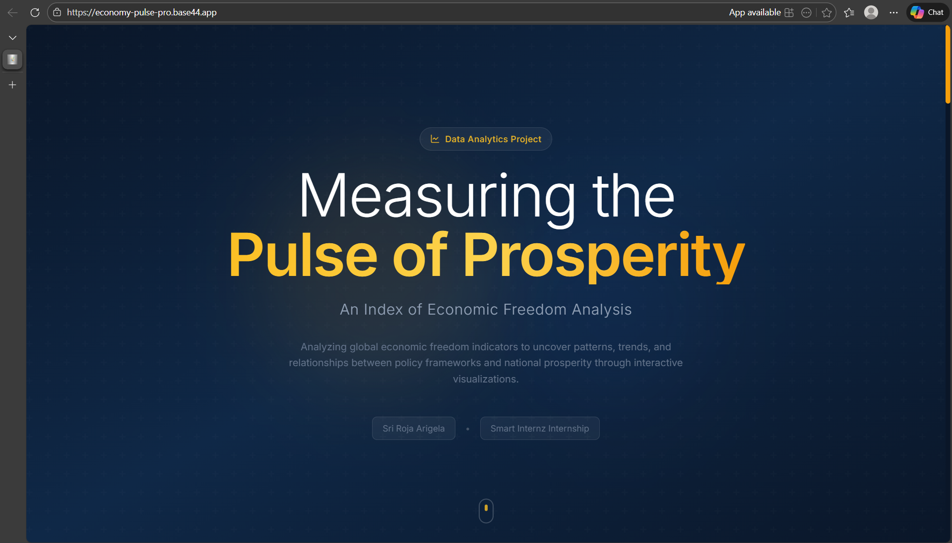

Dashboard:
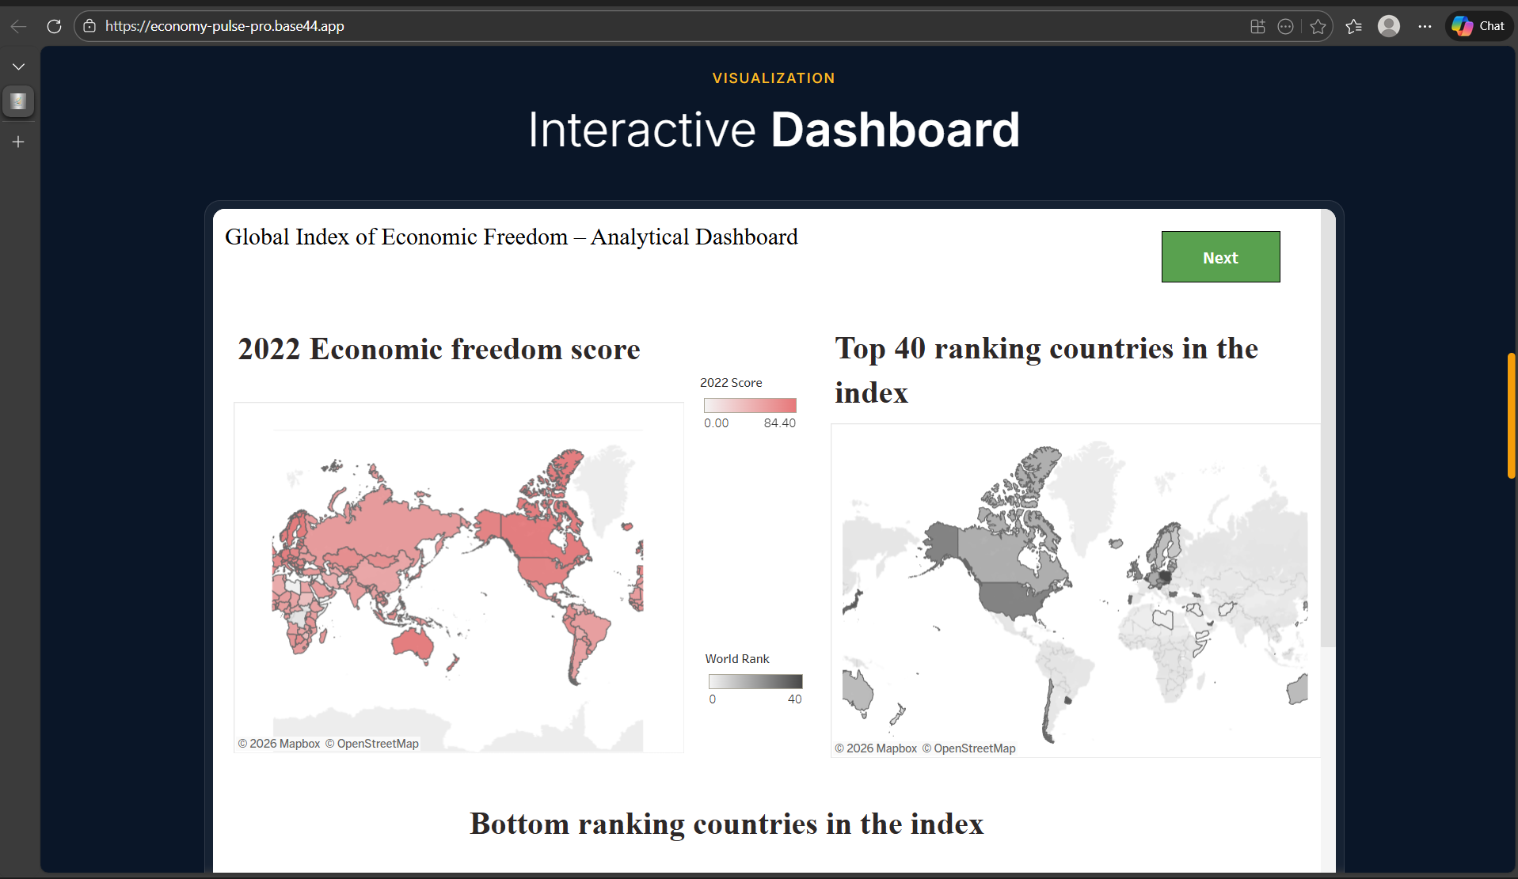

Story:
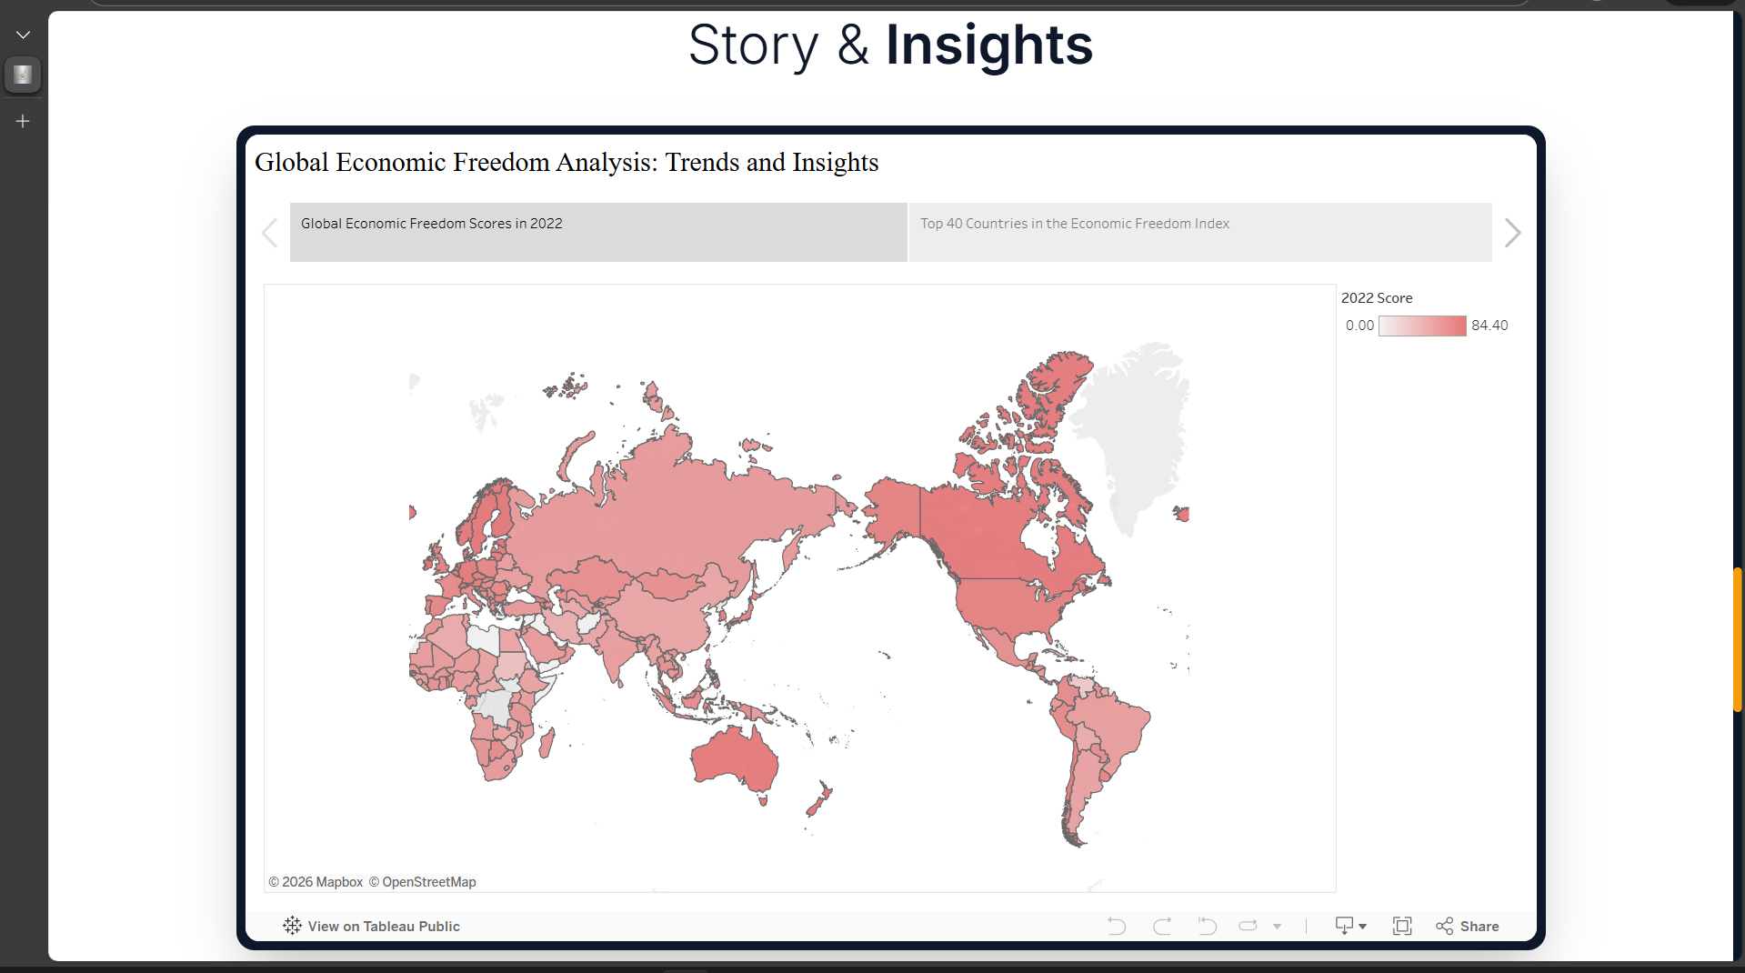

11. Conclusion
This project successfully demonstrates how data visualization can be used to measure and interpret global economic performance.
By analyzing the Index of Economic Freedom, we gained insights into how economic policies influence national prosperity.
The integration of Tableau dashboards with web development and GitHub publishing showcases practical skills in:
- Data analytics
- Visualization
- Web development
- Version control
- Project documentation
This project enhances understanding of global economic trends and strengthens real-world analytical skills.

12. Future Enhancements
- Add multi-year comparison
- Include predictive trend analysis
- Integrate advanced filters
- Add dynamic country comparison tool

